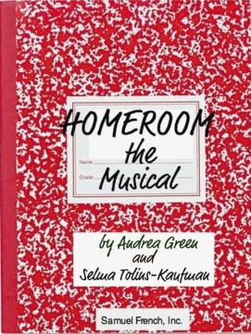
Audition information for
Homeroom the Musical

Thank you for auditioning for Homeroom the Musical. We wanted to give you some details about the show and potential time commitments before you audition. The performances for this production will be Friday, March 14 and Saturday, March 15 at 7:00pm. Rehearsal times are listed on your audition form that you will be required to turn in the evening of your audition.

Auditions will be held Monday, December 9 and Tuesday, December 10 from 6:00 – 9:00pm both nights in the middle school choir room. You will ONLY be required to choose between ONE of those days to audition, but you must come at 6:00 and plan to stay until 9:00 pm. Callbacks will be held on Wednesday, December 11 from 6:00- 9:00pm . The director may ask you to come back that evening, but not getting called back does not necessarily mean you will not be cast. Please sign-up for your audition in advance on the sheet hanging on the main office window.

There will be a mandatory cast member read-through at 3:00pm on Tuesday, December 17 and parent meeting immediately following the read-through at 5:15pm. If you are cast in this show, it is important that your commitment to the production becomes a priority. Rehearsals should be considered mandatory by all cast members. You will only need to be at those rehearsals that your character is scheduled for.

IMPORTANT: For auditions, you will be required to sing a song of your choice. Please bring the sheet music to your audition so the music director is able to accompany you on the piano. A’capella singing and recorded music will not be permitted. You must have your song memorized. Also, you will be taught a simple dance combination by a choreographer as part of your audition. Please wear comfortable clothing and shoes (tennis shoes are fine). Do not worry or stress about the auditions…we encourage everyone to come out and have fun with the process. Make sure your audition form is filled out entirely and make sure you have attached a photo of yourself (can be a copy of a school picture, snapshot, etc.) just so we can identify you during the auditions. REMEMBER TO BRING THIS FORM TO YOUR AUDITION.

Homeroom the Musical will be presented by the BBH Middle School PSO and Brecksville Theater on the Square. The show will be directed by an accomplished local theatre director and actress, Kimberly Bush.
Kim is very excited to return to the middle school to direct this show. Musician and middle school parent,
Julie Brown, will serve as the Music Director for the production.
Learn more about the show at www.homeroomthemusical.com If you have any questions about the auditions, please contact Brecksville Theater on the Square producer, Lori Reagan at 440-666-9407 or rgnclan@att.net.

Thank you,
PSO Co-Producers
Patricia Jarosz , pjj911@att.net 216-832-0311
Sheyenne Uhlir, sheyenne@uhlir.net 440-627-6988

